Rogan Page

Sean Morris

CS-340

17 Aug. 24

Grazioso Salvare Dashboard

Project Description

The Grazioso Salvare Dashboard is an interactive web application designed to visualize data from an animal shelter database. The dashboard allows users to view and filter data about animals and displays their locations on a map. The application is built using the Dash framework and MongoDB, providing a user-friendly interface and robust data management.

Required Functionality

1. Data Table: Displays a table of animal data with pagination, sorting, and row selection capabilities.
2. Map Visualization: Shows the location of selected animals on an interactive map.
3. Filtering: Allows users to filter the data based on rescue type.
4. Dynamic Updates: Updates the data table and map based on user interactions.

Screenshots

1. Dashboard Overview:

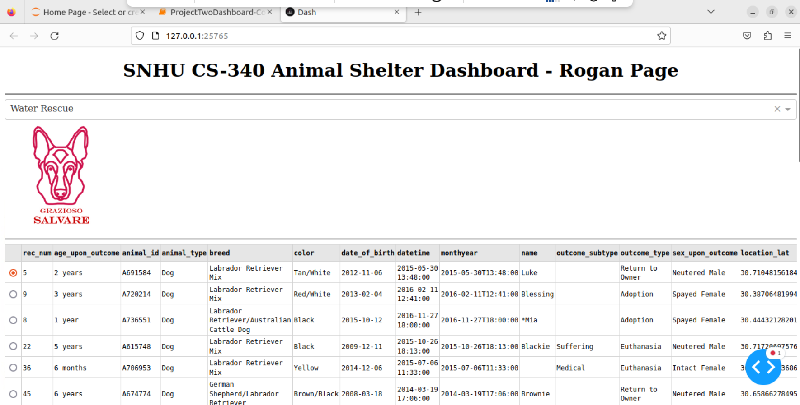

1. Filtered Data Table: 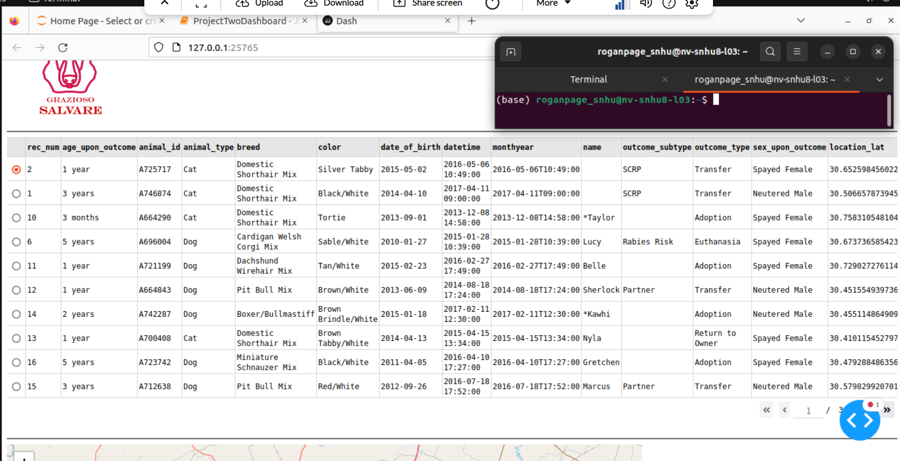
2. Map and Chart Visualization:

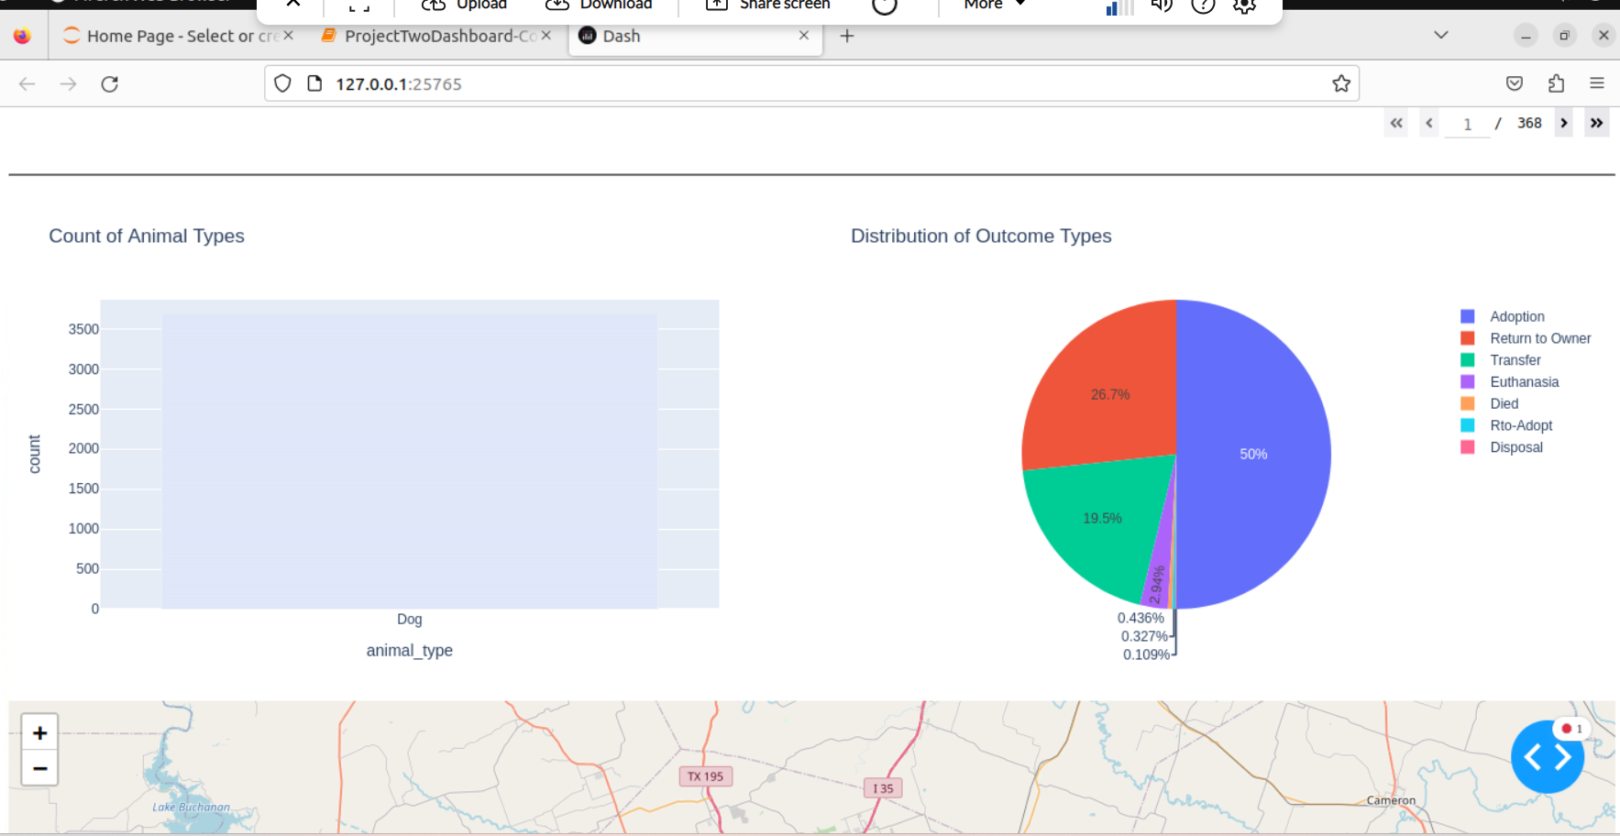

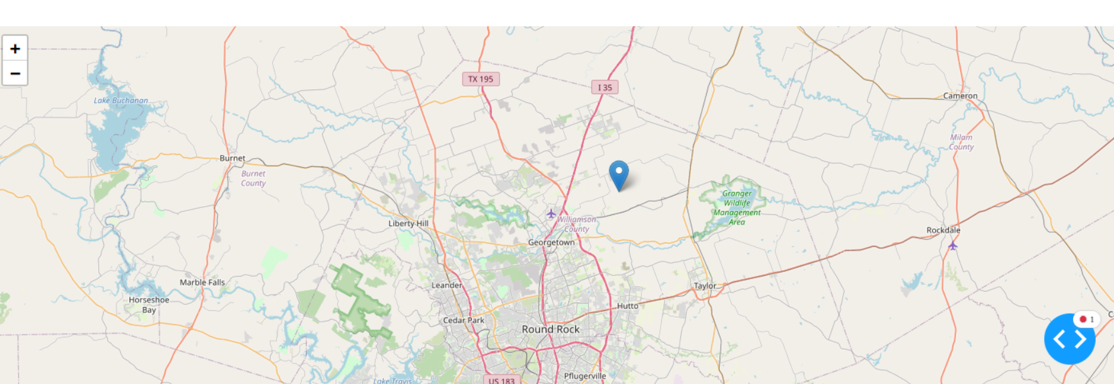

Tools and Rationale

* Dash Framework: Used for building the web application interface. Dash provides a robust way to create interactive web applications with Python, integrating well with Plotly for visualizations and components for creating interactive dashboards.
* Dash Leaflet: Provides the mapping components to display geographic data on the web application. It allows integration of interactive maps with customizable markers and popups.
* MongoDB: Chosen for its flexibility and scalability in handling the animal shelter data. MongoDB's document-oriented data model allows for easy storage and retrieval of data without the constraints of a traditional relational database. Its ability to handle unstructured data and complex queries made it a suitable choice for this project.
* JupyterDash: Used to run the Dash app within a Jupyter notebook environment, allowing for easy development and testing.

MongoDB and Its Integration

MongoDB was selected as the database model due to its flexibility in handling various data types and structures. Its JSON-like documents make it easy to store and retrieve complex data structures, which is ideal for managing diverse animal records. The Python pymongo library was used to interact with MongoDB, providing methods to perform CRUD operations and query data efficiently.

Dash Framework Overview

Dash is a Python framework for building analytical web applications. It combines the capabilities of Plotly for data visualization with a simple way to create interactive components. Key features include:

* Components: For building interactive UI elements such as graphs, tables, and dropdowns.
* Callbacks: To update the components dynamically based on user interactions.
* Layout: To define the structure and appearance of the web application.

Resources and Software

* Dash Framework: Dash Documentation
* Dash Leaflet: Dash Leaflet Documentation
* MongoDB: MongoDB Documentation
* JupyterDash: JupyterDash Documentation
* Python Libraries: pandas, plotly, numpy, matplotlib

Project Completion Steps

* Setup Environment: Installed necessary libraries and set up MongoDB database.
* Data Integration: Connected to MongoDB, fetched data, and prepared it for visualization.
* Develop Dashboard: Created the Dash application layout and implemented interactivity using callbacks.
* Testing: Verified functionality through screenshots and testing different scenarios.
* Deployment: Deployed the dashboard and ensured it is accessible and functional.

Challenges and Solutions

* Data Handling: Converting MongoDB data to a format suitable for Dash. Solution: Used pandas to convert MongoDB documents into DataFrames.
* Map Integration: Ensuring map markers correctly reflect data from the database. Solution: Implemented callbacks to dynamically update map markers based on selected data.
* Interactivity Issues: Managing dynamic updates and interactions between components. Solution: Used Dash callbacks effectively to synchronize data table selections with map updates.

Conclusion

The Grazioso Salvare Dashboard successfully meets the project's requirements by providing an interactive interface for visualizing and managing animal shelter data. With the use of modern web technologies and robust data handling capabilities, the dashboard offers a comprehensive tool for animal shelter management.